EURAMET comparison - Project number 1350
Comparison of sub-multiples of the kilogram

Technical protocol

Objectives

This technical protocol specifies the conditions of interlaboratory comparison of stainless steel mass standards between MIRS, Slovenia, MBM, Montenegro and HMI, Croatia.

The objectives of the comparison are to facilitate the demonstration of metrological equivalence between the participating national laboratories, and to check the capabilities of MBM and HMI to publish or improve, respectively, their calibration measurement capabilities (CMC).

Participants

Participant 1 (Coordinator and pilot laboratory)
Metrology Institute of the Republic of Slovenia (MIRS)
Grudnovo nabrezje 17
1000 Ljubljana
Slovenia
Phone: +386 1 24 42 732
Fax : +386 1 24 42 714
Contact person: Goran Grgić (goran.grgic@gov.si)

Participant 2
Montenegrin Bureau of Metrology (MBM)
Kralja Nikole 2
81000 Podgorica
Montenegro
Phone: + 382 20 601360
Fax: +382 20 634 651
Contact person: Tamara Bošković Begenišić (tamara.boskovic@metrologija.gov.me)

Participant 3
Hrvatski mjeriteljski institut
Ibrišimovićeva bb
HR-10000 Zagreb
Croatia
Phone: + 385 1 3704 979
Fax: + 385 1 3704 976
Contact person: Martina Periša Pisk (mpisk@hmi.hr)

Participant 4
Institute of Metrology of Bosnia and Herzegovina (IMBiH)
Augusta Brauna 2
(Laboratory address Dolina 6)
71 000 Sarajevo
Bosnia and Herzegovina
Phone: + 387 33 568 - 920
Fax: +387 33 568 - 909
Contact person: Šejla Ališić (sejla.alisic@met.gov.ba)

Participant 5
General Directorate of Metrology (DPM)
Autostrada “Tirane-Durres” km 8, Kashar
Tirane
Albania
Phone: +355 (0)68 2798 333
Fax: +355 4 2228 244
Contact person: Defrim Bulku (defrim.bulku@dpm.gov.al)

Participant 6
Slovenský metrologický ústav (SMU)
Karloveská 63
84255 Bratislava
Slovakia
Phone: +421 2 60294218
Fax: +421 2 65429592
Contact person: Laurenc Snopko (snopko@smu.gov.sk)

Transfer standards

The transfer standards for this comparison comprise three stainless steel cylindrical weights with a knob (OIML R111 design) of the following nominal masses: 200 g, 20 g, 2 g, and one german silver rectangular sheet weight (OIML R111 design) of the nominal mass 200 mg. The weights are housed in two containers as presented on Picture 1. They were produced by Mettler Toledo and purchased by MIRS in 1997.

Nominal mass | 200 g | 20 g | 2 g | 200 mg
Marking | * | ** | * | 1 *

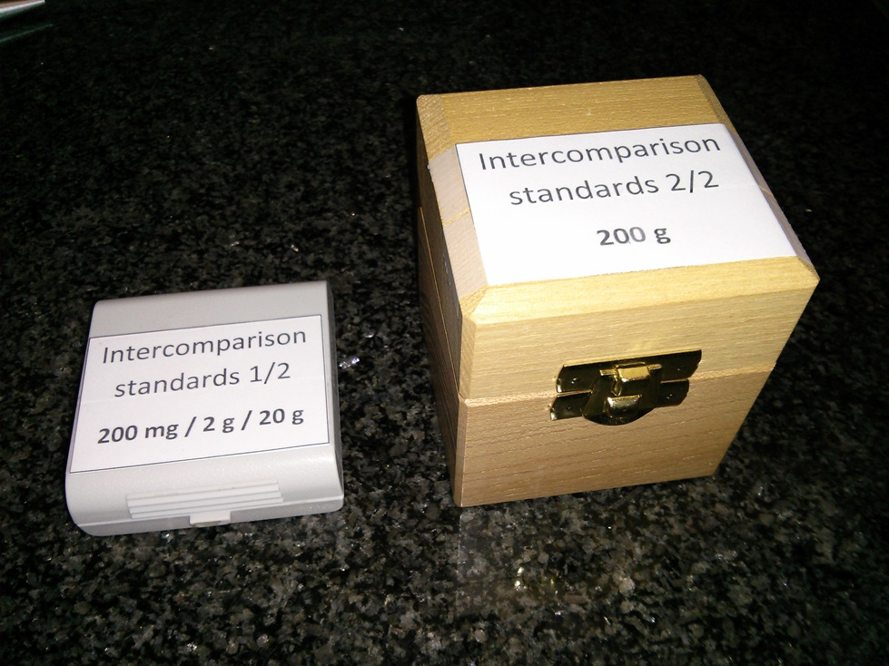

Picutre 1: Plastic (left) and wooden (right) container with standards

The density/volume, centres of gravity and the magnetic susceptibility of each mass standard (except for the 200 mg standard) are given as a part of the measurement report (Measurement Report.doc).

Stability of the standards has been monitored at the pilot laboratory.

Time schedule

Preliminary time schedule

Measurements at MIRS, Ljubljana: January 2015
Transport to HMI, Zagreb
Measurements at HMI, Zagreb: February 2015
Transport to MIRS, Ljubljana
Transport to MBM, Podgorica
Measurements at MBM, Podgorica: March 2015
Transport to IMBiH, Sarajevo
Measurements at IMBiH, Sarajevo: May 2015
Transport to DPM, Tirana
Measurements at DPM, Tirana: June 2015
Transport to MIRS, Ljubljana
Transport to SMU, Bratislava
Measurements at SMU, Bratislava: July 2015
Transport to MIRS, Ljubljana
Measurements at MIRS, Ljubljana: August 2015
Draft report expected: November 2015

Unpacking, handling and care of the standards

When the standards arrive at the participating laboratory, the transportation box and its contents should be checked for damage and missing items. A visual inspection of the surfaces of the standards should be made and the results noted on the measurement report. The pilot laboratory should be informed about the arrival and departure time and about the result of the visual inspection as soon as possible by email.

Every incident during handling of the transfer standards, where the standards may have been polluted or damaged, should be documented and communicated to the pilot laboratory as soon as possible. Also, the pilot laboratory should be informed about any delay or required change of the time schedule.

The standards should be stored at a place where they are protected from dust, aerosols and vapours all the time they are not in the balance, for example in their travelling containers or in a suitable clean environment protected from dust, drafts and vapour. If the weight is placed on a table, the table surface should be clean and covered by acid free tissue paper.

The transfer standards should be handled carefully and only ever with the appropriate tools. When being manipulated the weights should be handled with tongs or tweezers. The standards should never be touched with bare hands.

The standards should be wrapped in the acid free tissue paper provided before being put in their containers

Measurements to be performed

The participating laboratories shall determine the mass and conventional mass value of the transfer standards according their normal calibration procedure. An appropriate time should be allowed for the stabilisation of the weights following transportation (as specified in OIML R111 for class E1).

Before the mass determination, dust particles should be removed from the surface of the standard by a clean, soft brush. No further washing should be performed. After visual inspection for dust particles on the surface, the weights should be placed in the weighing chamber of the comparator.

All weighings should be performed in air. For the buoyancy correction, the air density should be determined using the laboratory’s standard procedure, specified on the annexed form.

Reporting

A completed measurement report (the form "Measurement report.doc") for the measurement results, data of the ambient conditions, instruments used and traceability of the participant's reference standards must be submitted to the coordinator for the results within two weeks after the completion of the measurements. All collected measurement reports will be then sent to MIRS, which will carry out the data analysis.

The pilot laboratory will provide a first draft of the comparison report within four weeks after the receipt of the results of the data analysis.

Transportation

The containers, as presented on the Picture 1, are packed in a cardboard box.

It is the responsibility of each laboratory to organize the transport to the next participant – by well-known courier or, preferably, by hand-carrying – and ensuring that all necessary customs and importation documents (ATA Carnet for Montenegro, Bosnia and Herzegovina and Albania) are in order.

Every incident, where the artefact may have been polluted or damaged, should be documented and communicated to the pilot laboratory as soon as possible. Also, the pilot laboratory should be informed about any delay or required change of the time schedule.

Financial aspects and insurance

Each participating laboratories is responsible for its own costs for the measurements, transportation and travel insurance as well as any damage that may occur within its country.

Annexed forms

Measurement Report

